|  |  |  |
| --- | --- | --- |
| **Supervisor** | SIR Muhammad Haris | |
| **Batch** | 2401F2 | |
| **Group** | C | |
| **Serial No.** | **Enrollment Number** | **Student Name** |
| 1. | Student1547317 | FAIQ ASHFAQUE |
| 2. | Student1545845 | ABDULLAH GHFOOR |
| 3. | Student1546846 | BILAL KHAN |
|  |  |  |

# Navbar:

Using the navbar, the user can navigate through various categories. We have total 7 items in Navbar, which are further classified as:

* Navbar
* Home page
* card
* FOOTER

BrandPage includes 5 brands (Home Page, Residential Harvesting, Commercial Harvesting, Product, Contact Us ). Page include 5 more pages.

Products slider includes our collections items and its Itoms .

Navbar contains about our company, services, account and our website .



# Home Page:

# 

**card**

We have total 5 Pages ; each Pages contains 2 brands. And every item contains products details page,.

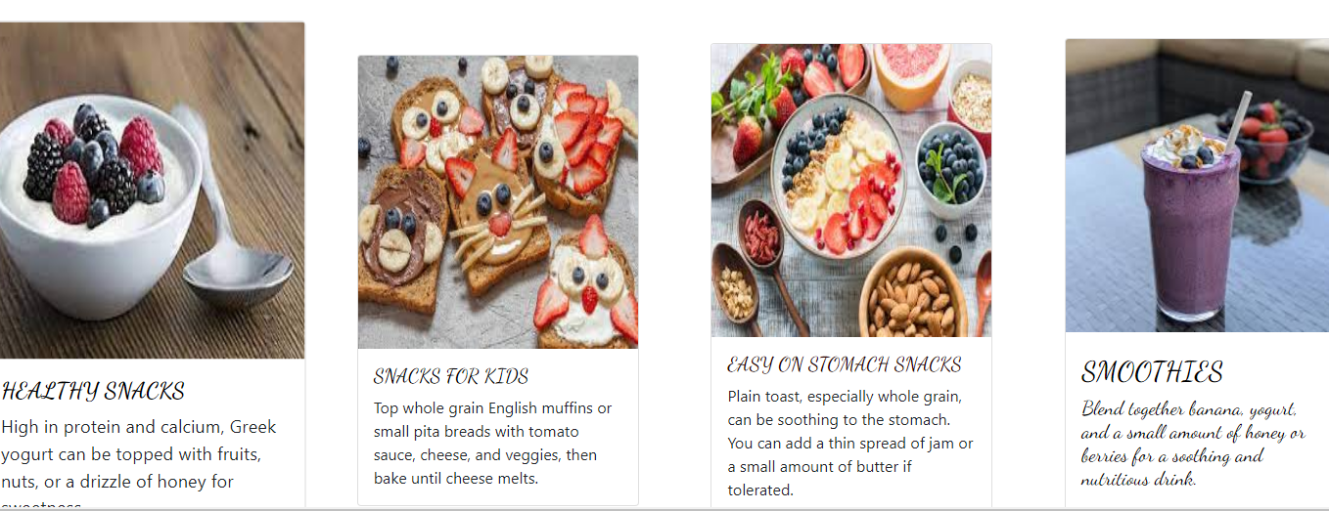

**Footer Page:**

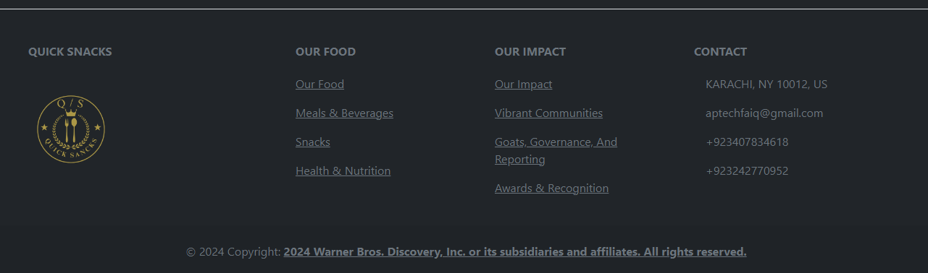

**Contact Us Page**

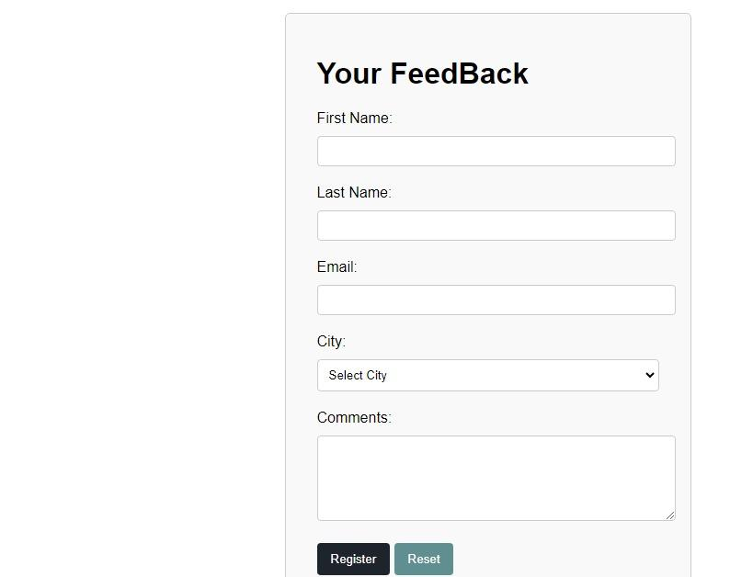

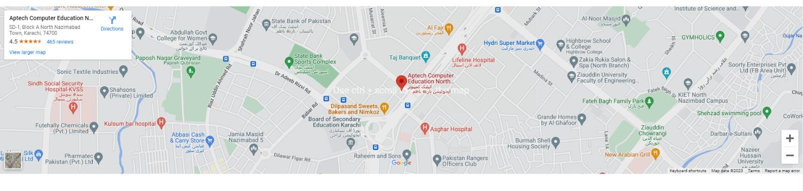

**Summary:**

A quick snack summary could include:

- Snacks are small, easily consumable portions of food typically eaten between meals.

- They can be sweet or savory and range from fruits and nuts to chips, cookies, or sandwiches.

- Quick snacks are convenient for satisfying hunger or cravings without a full meal.

- Popular choices include granola bars, yogurt, popcorn, and fresh fruit.

- Consider nutritional value and portion size when choosing a snack for a balanced diet.